🟢 Bandit Level 0 → Level 1
Goal: Log in to Bandit Level 0, then find the password for bandit1.
1️⃣ Connect to Bandit
Open your terminal and run:
ssh bandit0@bandit.labs.overthewire.org -p 2220
When asked for the password, enter: bandit0
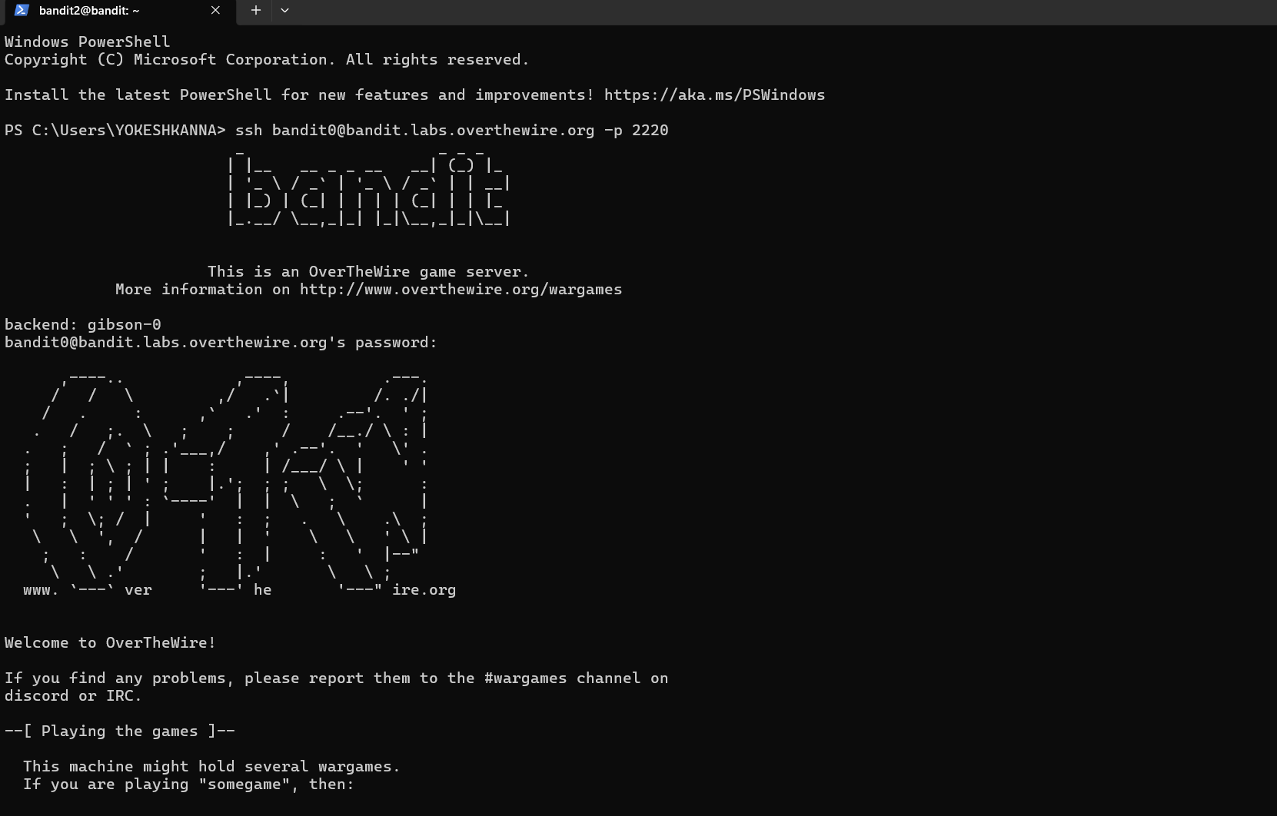
Then 2️⃣ Find the password
Once logged in:
Command ls -al to view hidden files
You'll see:
readme
Read it using:
cat readme
The output is the password for bandit1 🔑 is 6y2kwnwK6grgvwvpvLaa2T1cpFEKOhNR
